

**AMERICAN INTERNATIONAL UNIVERSITY–BANGLADESH**

**FACULTY OF SCIENCE & TECHNOLOGY**

**FALL 2022-2023**

**COURSE NAME**

INTRODUCTION TODATABASE

**SECTION:** C

**GROUP NO:** 6

**PROJECT TITLE**

VEHICLE CONTROL & INFORMATION MANAGEMENT SYSTEM

**SUPERVISED BY**

**MST. TASNIM PARVEEN**

**GROUP INFO**

|  |  |
| --- | --- |
| **NAME** | **ID** |
| 1.RIFAH SANZIDA | 22-47154-1 |
| 2.MD SAMIN YEASER | 22-47139-1 |
| 3.TAHMIDA ALAMGIR | 22-46020-1 |

**DATE OF SUBMISSION:** 26 DECEMBER 2022

**TABLE OF CONTENTS**

**TOPICS PAGE NO**

1. INTRODUCTION 3
2. SCENARIO DESCRIPTION 3
3. ER DIAGRAM 4
4. NORMALIZATION 5
5. TABLE CREATION 11
6. DATA INSERTION 11
7. QUERY DESIGN 28
8. CONCLUSION AND FUTURE PLAN 39

**INTRODUCTION**

IN BANGLADESH WE CANNOT EASILY VERIFY A VEHICLE OR A DRIVER DUE TO SHORTEST OF RESOURCES. LAW ENFORCEMENT UNITS CANNOT PUNISH ANY VEHICLE JUST BY SEEING THE NUMBER OF THE VEHICLE. IN THIS PROJECT WE TRY TO MANAGE THIS SITUATION. WE TRY OUR BEST TO MAKE A GOOD MANAGEMENT BY WHICH LAW ENFORCEMENT UNITS CAN EASILY VERIFY A VEHICLE. THEY CAN EASILY FIND OUT ALL THE DETAILS ABOUT THAT VEHICLE, AND IF THERE ARE ANY OTHER CASES AGAINST THAT VEHICLE BY USING OUR MANAGEMENT SYSTEM.

**SCENARIO DESCRIPTION**

A VEHICLE CONTROL AND INFORMATION MANAGEMENT SYSTEM IS BASICALLY CONTROLLING THE VEHICLES IN A SYSTEMATIC WAY.VEHICLE IS UNIQUELY IDENTIFIED BY VEHICLE_ NUMBER. OTHER ATTRIBUTES OF A VEHICLE ARE VEHICLE_TYPE, VEHICLE_MODEL, VEHICLE_REG_DATE. A DRIVER DRIVES A VEHICLE. DRIVER IS ALSO IDENTIFIED BY DRIVER_LICENSE_NUMBER. DRIVER HAS DRIVER_NAME, DRIVER_PHONE_NO, AND DRIVER_HOME_DIST. AN OWNER OWNS MANY VEHICLES. AN OWNER IS IDENTIFIED BY OWNER_NID. AN OWNER ALSO HAS OWNER_NAME, OWNER_PHONE_NO, OWNER_ADDRESS, AND OWNER_EMAIL. MANY POLICE OBSERVES MANY VEHICLES. POLICE HAS UNIQUE POLICE_ID. POLICE ALSO HAS POLICE_NAME, POLICE_PHONE_NO, POLICE_WORKING_CITY, AND POLICE_WORKING_ZONE. POLICE GIVES MANY CASES.POLICE CAN PUNISH DRIVERS BY ASSIGNING CASES AGAINST VEHICLES CASE HAS UNIQUE CASE_NO AS PRIMARY KEY. CASE ALSO HAS CASE_DATE, CASE_INFO, AND CASE_FINE.

**ER DIAGRAM**

**(BEFORE NORMALIZATION)**

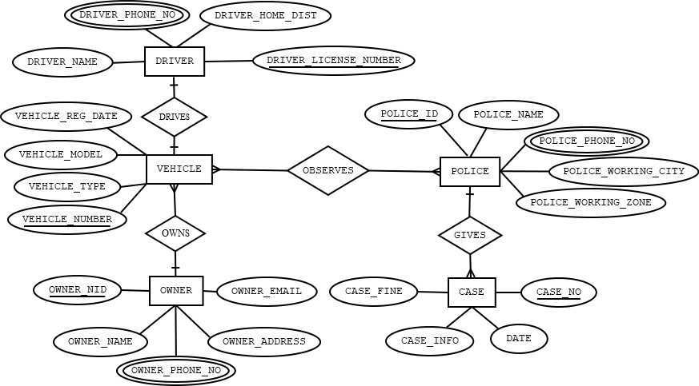

**NORMALIZATION**

**DRIVER** **DRIVES VEHICLE**

**UNF:**

DRIVES(VEHICLE_REG_DATE,VEHICLE_MODEL,VEHICLE_TYPE, VEHICLE_NUMBER,DRIVER_NAME,DRIVER_PHONE_NO, DRIVER_HOME_DIST,DRIVER_LICENSE_NUMBER)

**1NF:**

DRIVER_PHONE_NO IS MULTIVALUED ATTRIBUTE.

**2NF:**

1.VEHICLE_NUMBER,VEHICLE_MODEL,VEHICLE_REG_DATE,VEHICLE_TYPE,

2. DRIVER_LICENSE_NUMBER,DRIVER_NAME,DRIVER_PHONE_NO, DRIVER_HOME_DIST,

**3NF:**

THERE IS NO TRANSITIVE DEPENDENCY.

1.VEHICLE_NUMBER,VEHICLE_MODEL,VEHICLE_REG_DATE, VEHICLE_TYPE, DRIVER_LICENSE_NUMBER

2. DRIVER_LICENSE_NUMBER,DRIVER_NAME, DRIVER_PHONE_NO, DRIVER_HOME_DIST

**OWNER OWNS VEHICLE**

**UNF:**

OWNS(VEHICLE_REG_DATE,VEHICLE_MODEL,VEHICLE_TYPE, VEHICLE_TYPE,DRIVER_LICENSE_NUMBER,OWNER_NID, OWNER_NAME,OWNER_PHONE_NO,OWNER_ADDRESS, OWNER_EMAIL)

**1NF:**

OWNER_PHONE_NO IS MULTIVALUED ATTRIBUTE.

**2NF:**

1.VEHICLE_NUMBER,VEHICLE_MODEL,VEHICLE_REG_DATE, VEHICLE_TYPE 2.OWNER_NID,OWNER_NAME,OWNER_PHONE_NO,OWNER_ADDRESS, OWNER_EMAIL, VEHICLE_NUMBER

**3NF:**

THERE IS NO TRANSITIVE DEPENDENCY.

1.VEHICLE_NUMBER,VEHICLE_MODEL,VEHICLE_REG_DATE, VEHICLE_TYPE

2. OWNER_NID, OWNER_NAME,OWNER_PHONE_NO,OWNER_ADDRESS, OWNER_EMAIL, VEHICLE_NUMBER

**POLICE GIVES CASE**

**UNF:**

GIVE(POLICE_ID,POLICE_NAME,POLICE_PHONE_NO, POLICE_WORKING_CITY,POLICE_WORKING_ZONE,CASE_NO,DATE, CASE_INFO, CASE_FINE)

**1NF:**

POLICE_PHONE_NO IS MULTIVALUED ATTRIBUTE.

**2NF:**

1.POLICE_ID,POLICE_NAME,POLICE_PHONE_NO, POLICE_WORKING_CITY,POLICE_WORKING_ZONE

2. CASE_NO, DATE, CASE_INFO, CASE_FINE, POLICE_ID

**3NF:**

THERE IS NO TRANSITIVE DEPENDENCY.

1.POLICE_ID,POLICE_NAME,POLICE_PHONE_NO, POLICE_WORKING_CITY,POLICE_WORKING_ZONE

2. CASE_NO, DATE, CASE_INFO, CASE_FINE, POLICE_ID

**POLICE OBSERVES VEHICLE**

**UNF:**

OBSERVES(VEHICLE_MODEL,VEHICLE_REG_DATE,VEHICLE_TYPE, VEHICLE_TYPE,POLICE_ID,POLICE_NAME,POLICE_PHONE_NO, POLICE_WORKING_CITY,POLICE_WORKING_ZONE)

**1NF:**

POLICE_PHONE_NO IS MULTIVALUED ATTRIBUTE

**2NF:**

**1.**VEHICLE_NUMBER,VEHICLE_MODEL,VEHICLE_REG_DATE, VEHICLE_TYPE

**2.**POLICE_ID,POLICE_NAME,POLICE_PHONE_NO, POLICE_WORKING_CITY,POLICE_WORKING_ZONE

**3.**VP_ID, VEHICLE_MODEL,POLICE_ID

**3NF:**

THERE IS NO TRANSITIVE DEPENDENCY.

**1.**VEHICLE_MODEL,VEHICLE_REG_DATE,VEHICLE_TYPE,

**2.**POLICE_ID,POLICE_NAME,POLICE_PHONE_NO, POLICE_WORKING_CITY,POLICE_WORKING_ZONE

**3.**VP_ID, VEHICLE_MODEL, POLICE_ID

**TOTAL TABLE:**

1.VEHICLE_NUMBER,VEHICLE_MODEL,VEHICLE_REG_DATE, VEHICLE_TYPE, DRIVER_LICENSE_NUMBER

2.DRIVER_LICENSE_NUMBER,DRIVER_NAME, DRIVER_PHONE_NO, DRIVER_HOME_DIST

3.VEHICLE_NUMBER,VEHICLE_MODEL,VEHICLE_REG_DATE, VEHICLE_TYPE

4. OWNER_NID, OWNER_NAME,OWNER_PHONE_NO,OWNER_ADDRESS, OWNER_EMAIL, VEHICLE_NUMBER

5.POLICE_ID,POLICE_NAME,POLICE_PHONE_NO, POLICE_WORKING_CITY,POLICE_WORKING_ZONE

6. CASE_N0, DATE, CASE_INFO, CASE_FINE, POLICE_ID

7.VEHICLE_NUMBER,VEHICLE_MODEL,VEHICLE_REG_DATE, VEHICLE_TYPE

8.POLICE_ID,POLICE_NAME,POLICE_PHONE_NO, POLICE_WORKING_CITY, POLICE_WORKING_ZONE

9.VP_ID, VEHICLE_NUMBER, POLICE_ID

**FINAL TABLE:**

1.VEHICLE_NUMBER,VEHICLE_MODEL,VEHICLE_REG_DATE,VEHICLE_TYPE, DRIVER_LICENSE_NUMBER

2. DRIVER_LICENSE_NUMBER,DRIVER_NAME, DRIVER_PHONE_NO, DRIVER_HOME_DIST

3. OWNER_NID, OWNER_NAME,OWNER_PHONE_NO,OWNER_ADDRESS, OWNER_EMAIL, VEHICLE_NUMBER

4.POLICE_ID,POLICE_NAME,POLICE_PHONE_NO, POLICE_WORKING_CITY,POLICE_WORKING_ZONE

5. CASE_N0, DATE, CASE_INFO, CASE_FINE, POLICE_ID

6.VP_ID, VEHICLE_NUMBER, POLICE_ID

**TABLE CREATION**

**VEHICLE TABLE:**

|  |
| --- |
| CREATE TABLE VEHICLE(  VEHICLE_NUMBER NUMBER(10) CONSTRAINT VEHICLE_NUMBER_PK PRIMARY KEY,  VEHICLE_REG_DATE VARCHAR(20),  VEHICLE_TYPE VARCHAR2(20) NOT NULL,  VEHICLE_MODEL VARCHAR2(30) UNIQUE,  DRIVER_LICENSE_NUMBER NUMBER(20) CONSTRAINT D_LICENCE_NUMBER_FK REFERENCES DRIVER  )  DESC DRIVER; |

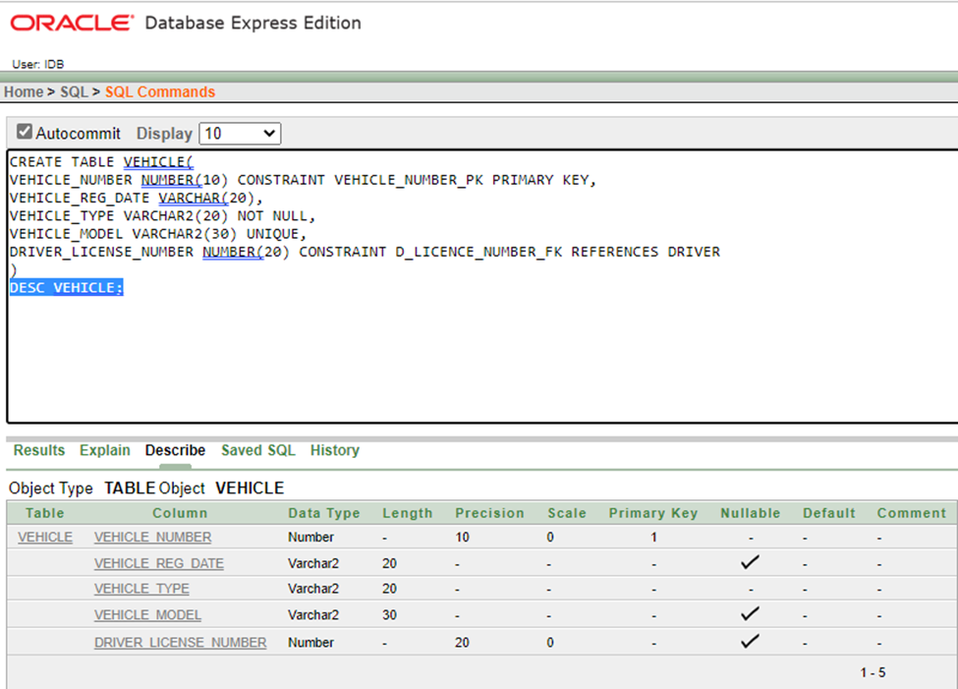

**DRIVER TABLE:**

|  |
| --- |
| CREATE TABLE DRIVER(  DRIVER_LICENSE_NUMBER NUMBER (15)CONSTRAINT DRIVER_LICENSE_NUMBER_PK PRIMARY KEY,  DRIVER_NAME VARCHAR2(30) NOT NULL,  DRIVER_PHONE_NO NUMBER(15) UNIQUE,  DRIVER_HOME_DIST VARCHAR2(15)  );  DESC DRIVER; |

**OWNER TABLE:**

|  |
| --- |
| CREATE TABLE OWNER(  OWNER_ID NUMBER(15) CONSTRAINT OWNER_ID_PK PRIMARY KEY,  OWNER_NAME VARCHAR2(30),  OWNER_PHONE_NO NUMBER(15) UNIQUE,  OWNER_ADDRESS VARCHAR2(40),  OWNERE_MAIL VARCHAR2(40) UNIQUE,  VEHICLE_NUMBER NUMBER(10) CONSTRAINT VEHICLE_OWNER_FK REFERENCES VEHICLE(VEHICLE_NUMBER)  );  DESC OWNER; |

**POLICE TABLE:**

|  |
| --- |
| CREATE TABLE POLICE(  POLICE_ID NUMBER(10) CONSTRAINT POLICE_ID_PK PRIMARY KEY,  POLICE_NAME VARCHAR2(30),  POLICE_PHONE_NO_1 NUMBER(15) UNIQUE,  POLICE_WORKING_CITY VARCHAR2(10),  POLICEWORKINGZONE VARCHAR2(10)  );  DESC POLICE; |

**CASE TABLE:**

|  |
| --- |
| CREATE TABLE CASE(  CASE_NO NUMBER(10) CONSTRAINT CASE_NO_PK PRIMARY KEY,  CASE_DATE DATE,  CASE_INFO VARCHAR2(40),  CASE_FINE NUMBER(8),  POLICE_ID NUMBER(20) CONSTRAINT P_ID_FK REFERENCES POLICE(POLICE_ID)  );  DESC CASE; |

**VP TABLE:**

|  |
| --- |
| CREATE TABLE VP(  VP_ID NUMBER(20) CONSTRAINT VP_ID_PK PRIMARY KEY,  POLICE_ID NUMBER(20) CONSTRAINT PO_ID_FK REFERENCES POLICE(POLICE_ID),  VEHICLE_NUMBER NUMBER(20) CONSTRAINT VEHI_NUMBER_FK REFERENCES VEHICLE(VEHICLE_NUMBER)  );  DESC VP; |

**DATA INSERTION**

**VEHICLE TABLE:**

INSERT INTO VEHICLE VALUES (132868,TO_DATE('12-APR-2016','DD-MM-YYYY'),'CAR','COROLLA',1285518);

INSERT INTO VEHICLE VALUES (142569,TO_DATE('17-OCT-2012','DD-MM-YYYY'),'BIKE','APACE',1286619);

INSERT INTO VEHICLE VALUES (256563,TO_DATE('14-JUN-2018','DD-MM-YYYY'),'BUS','HYUNDAI',1284420);

INSERT INTO VEHICLE VALUES (177045,TO_DATE('02-FEB-2014','DD-MM-YYYY'),'TRUCK','TATA'1185621);

INSERT INTO VEHICLE VALUES (166559,TO_DATE('03-MAR-2013','DD-MM-YYYY'),'CAR','ALLION',1185519);

INSERT INTO VEHICLE VALUES (154587,TO_DATE('24-OCT-2015','DD-MM-YYYY'),'CAR','PREMIO',1188692);

INSERT INTO VEHICLE VALUES (125253,TO_DATE('11-NOV-2011','DD-MM-YYYY'),'BUS','SCANIA',1356695);

INSERT INTO VEHICLE VALUES (278565,TO_DATE('12-SEP-2020','DD-MM-YYYY'),'CAR','BMW',1458558);

INSERT INTO VEHICLE VALUES (254548,TO_DATE('10-JUL-2019','DD-MM-YYYY'),'BIKE','GIXER',1178899);

INSERT INTO VEHICLE VALUES (241963,TO_DATE('22-AUG-2017','DD-MM-YYYY'),'TRUCK','EICHER',1150258);

SELECT * FROM VEHICLE;

**DRIVER TABLE:**

INSERT INTO DRIVER VALUES (1285518,'HASAN ALI',01317810827,'DHAKA');

INSERT INTO DRIVER VALUES (1286619,'RAFI AHMED',01715040513,'RAJSHAHI');

INSERT INTO DRIVER VALUES (1284420,'RUBEL HASAN',01767808817,'CUMILLA');

INSERT INTO DRIVER VALUES (1185621,'AHNAF SAYEM',01993927063,'BARISAL');

INSERT INTO DRIVER VALUES (1185519,'NAYEEM AHMED',01456985258,'NATORE');

INSERT INTO DRIVER VALUES (1188692,'AMINUL ISLAM',01955696969,'THAKURGAO');

INSERT INTO DRIVER VALUES (1356695,'SHAFWAN AHMED',01836965858,'DHAKA');

INSERT INTO DRIVER VALUES (1458558,'SABIT HASAN',01535131063,'DHAKA');

INSERT INTO DRIVER VALUES (1178899,'PANTHO AHMED',01818971458,'GAZIPUR');

INSERT INTO DRIVER VALUES (1150258,'DIPTO HASAN',01456244569,'JOYPURHAT');

SELECT * FROM DRIVER;

**OWNER TABLE:**

INSERT INTO OWNER VALUES (1212585,'SHATABDI SARKER',01928381122,'DOCTORPARA,FENI', 'SHATABDI22@GMAIL.COM',154587);

INSERT INTO OWNER VALUES (9999869,'UMAIYA TAHIYAT BUSHRA',01928388895,'DOCTORPARA,FENI', 'TAHIYAT11@GMAIL.COM',125253);

INSERT INTO OWNER VALUES (7788585,'MD. ABDUR ROUF',01928381478,'KHILGAON,DHAKA', 'ABDUR78@GMAIL.COM',278565);

INSERT INTO OWNER VALUES (6653585,'ZAFIR KEN ZAMAN',01928384633,'UTTORA,DHAKA', 'ZAFIR11@GMAIL.COM',254548);

INSERT INTO OWNER VALUES (1266558,'DIPTO ROY',01928385565,'MALIBAGH,DHAKA', 'DIPTO99@GMAIL.COM',241963);

SELECT * FROM OWNER;

**POLICE TABLE:**

INSERT INTO POLICE VALUES (20235,'KIBRIA HOSSAIN',01928382457,'DHAKA','UTTORA');

INSERT INTO POLICE VALUES (20236,'RUBEL ALI',01928385898,'DHAKA','MOGHBAZAR');

INSERT INTO POLICE VALUES (20252,'GOLAM AHMED',01928380295,'SYHLET','AIRPORT');

INSERT INTO POLICE VALUES (21285,'RAKIB HOSSAIN',01928345496,'RAJSHAHI','STATION');

INSERT INTO POLICE VALUES (45852,'RAJIB KHAN',01928303490,'BARISAL','ILISHMOR');

INSERT INTO POLICE VALUES (25692,'REDWAN AHMED',01928092587,'KHULNA','KHULNA');

INSERT INTO POLICE VALUES (48528,'RAJI KHAN',01928782257,'GAZIPUR','CHONDRA');

INSERT INTO POLICE VALUES (58282,'ZERIN AHMED',01928522997,'SAVAR','NOBINOGOR');

INSERT INTO POLICE VALUES (45823,'NAYEEMKHAN',01928389905,'CHANDPUR','MOTLOB');

INSERT INTO POLICE VALUES (45825,'RAFSANCHOWDHURY',01928345404,'CHITTAGONG','PORTAREA');

SELECT *FROM POLICE;

**CASE TABLE:**

CREATE SEQUENCE CASE_CASENO

INCREMENT BY 1

START WITH 101

MAXVALUE 20000

NOCACHE

NOCYCLE;

INSERT INTO CASE VALUES (CASE_CASENO.NEXTVAL,TO_DATE('12-MAY-2018','DD-MM-YYYY'),'HIGHSPEED',5000,20235);

INSERT INTO CASE VALUES (CASE_CASENO.NEXTVAL,TO_DATE('17-OCT-2016','DD-MM-YYYY'),'BREAK SIGNAL',6500,20236);

INSERT INTO CASE VALUES (CASE_CASENO.NEXTVAL,TO_DATE('20-JUN-2021','DD-MM-YYYY'),'HIGHSPEED',8000,20252);

INSERT INTO CASE VALUES (CASE_CASENO.NEXTVAL,TO_DATE('02-FEB-2022','DD-MM-YYYY'),'MODIFIED CAR',3000,21285);

INSERT INTO CASE VALUES (CASE_CASENO.NEXTVAL,TO_DATE('03-MAR-2019','DD-MM-YYYY'),'HIGHSPEED',8000,45852);

INSERT INTO CASE VALUES (CASE_CASENO.NEXTVAL,TO_DATE('20-NOV-2020','DD-MM-YYYY'),'HEADLIGHT MISSING',1500,25692);

INSERT INTO CASE VALUES (CASE_CASENO.NEXTVAL,TO_DATE('16-OCT-2022','DD-MM-YYYY'),'BREAK SIGNAL',10000,48528);

INSERT INTO CASE VALUES (CASE_CASENO.NEXTVAL,TO_DATE('13-DEC-2022','DD-MM-YYYY'),'ACCIDENT',15000,58282);

INSERT INTO CASE VALUES (CASE_CASENO.NEXTVAL,TO_DATE('15-JUL-2021','DD-MM-YYYY'),'BREAKLIGHT MISSING',2000,45823);

INSERT INTO CASE VALUES (CASE_CASENO.NEXTVAL,TO_DATE('22-AUG-2017','DD-MM-YYYY'),'WRONG WAY USE',20000,45825);

SELECT * FROM CASE;

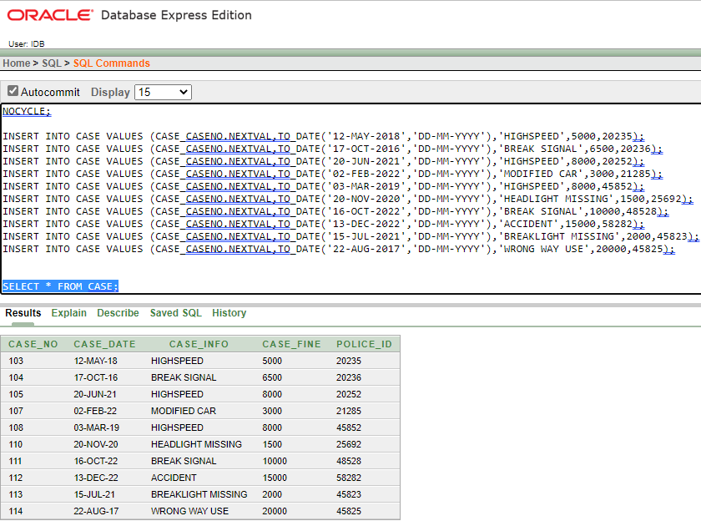

**VP TABLE:**

INSERT INTO VP VALUES (123,20235,132868);

INSERT INTO VP VALUES (234,20236,142569);

INSERT INTO VP VALUES (345,20252,256563);

INSERT INTO VP VALUES (456,21285,177045);

INSERT INTO VP VALUES (567,45852,166559);

INSERT INTO VP VALUES (678,25692,154587);

INSERT INTO VP VALUES (789,48528,125253);

INSERT INTO VP VALUES (890,58282,278565);

INSERT INTO VP VALUES (901,45823,254548);

INSERT INTO VP VALUES (912,45825,241963);

SELECT * FROM VP;

**QUERY DESIGN**

**FUNCTION**

**1.SINGLE ROW:**

• WRITE A QUERY TO DISPLAY THE OWNER NAME IN UPPER

CASE?

ANSWER: SELECT UPPER(OWNER_NAME) FROM OWNER;

**2.AGGREGATE:**

• DISPLAY THE AVERAGE AMOUNT OF CASE FINE?

ANSWER: SELECT AVG(CASE_FINE) FROM CASE;

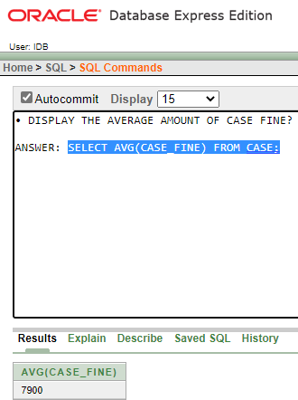

**SUBQUERY**

**1.SINGLE ROW :**

• DISPLAY THE CASE NO, CASE INFORMATION AND DATE OF CASE

WHOSE CASE FINE IS MINIMUM?

ANSWER: SELECT CASE_NO, CASE_INFO, CASE_DATE FROM CASE WHERE CASE_FINE = ( SELECT MIN(CASE_FINE) FROM CASE );

* Display Maximum MODEL of VEHICLE.

ANSWER: SELECT VEHICLE_NUMBER,VEHICLE_MODEL FROM

VEHICLE WHERE VEHICLE_MODEL = (SELECT

Max(VEHICLE_MODEL) FROM VEHICLE);

**2.MULTIPLE ROW:**

• DISPLAY THE CASE NO AND CASE INFORMATION WHICH CASES

FINE ARE GREATER THAN THE MODIFIED CAR CASE?

ANSWER: SELECT CASE_NO,CASE_INFO FROM CASE WHERE

CASE_FINE > ( SELECT CASE_FINE FROM CASE WHERE CASE_INFO

= 'MODIFIED CAR');

* DISPLAY ALL THE VEHICLE'S NAME WHOSE REG DATE ARE GRATER THAN 2013 ?

ANSWER: SELECT *FROM VEHICLE WHERE VEHICLE_REG_DATE>ALL(SELECT VEHICLE_REG_DATE FROM VEHICLE WHERE VEHICLE_MODEL='BMW' );

**JOINING**

**1. EQUI JOINING:**

* SHOW ALL THE OWNER INFORMATION WHO OWNS CAR?

ANSWER: SELECT O.* FROM OWNER O, VEHICLE V WHERE

O.VEHICLE_NUMBER = V.VEHICLE_NUMBER AND

VEHICLE_TYPE='CAR';

**2.OUTER JOINING:**

* SHOW ALL THE OWNERNAME, ID, VEHICLE REG DATE OF ALL THE VEHICLES?

ANSWER: SELECT OWNER_NAME, OWNER_ID, VEHICLE_REG_DATE

FROM OWNER O, VEHICLE V WHERE O. VEHICLE_NUMBER (+) = V.

VEHICLE_NUMBER

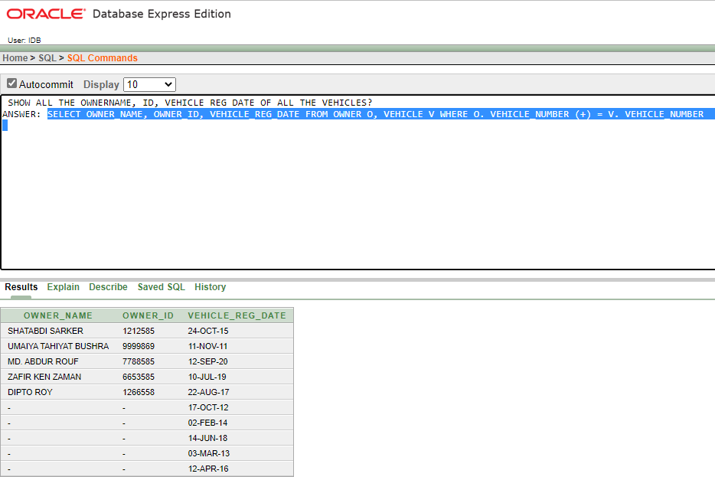

**3.SELF JOINING:**

* DISPLAY POLICE INFORMATION WHERE WORKING City and ZONE IS SAME.

ANSWER: SELECT P. POLICE_ID, P. POLICE_WORKING_CITY ,O.POLICEWORKINGZONE FROM POLICE P, POLICE O WHERE P. POLICE_WORKING_CITY = O.POLICEWORKINGZONE;

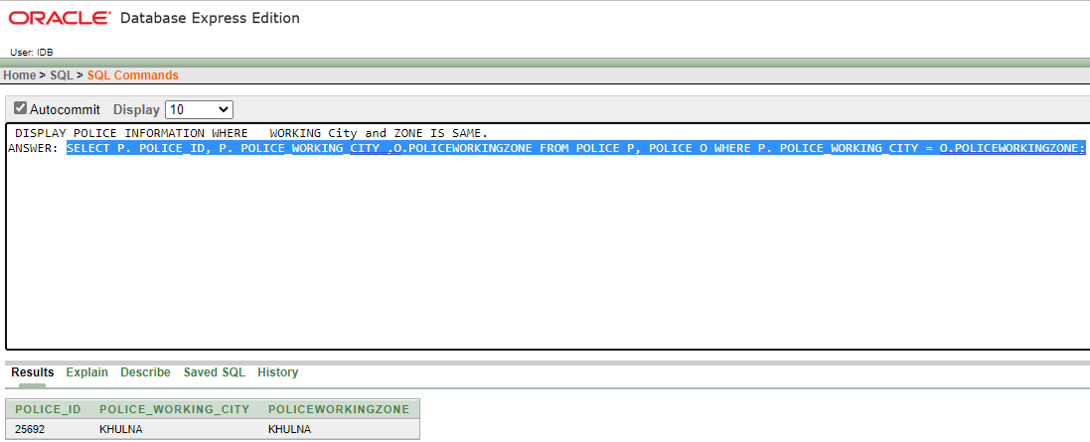

**VIEW**

**1. SIMPLE VIEW:**

* CREATE A VIEW CALLED DRIVER_LICENCE_NUMBER BASED

ON DRIVER_NAME,DRIVER_PHONE_NO WHERE

DRIVER_LICENSE_NUMBER=12855.

ANSWER: CREATE VIEW DRIVER_LICENCE_NUMBER AS SELECT DRIVER_NAME, DRIVER_PHONE_NO FROM DRIVER WHERE DRIVER_LICENSE_NUMBER = '12855'

SELECT * FROM DRIVER_LICENCE_NUMBER

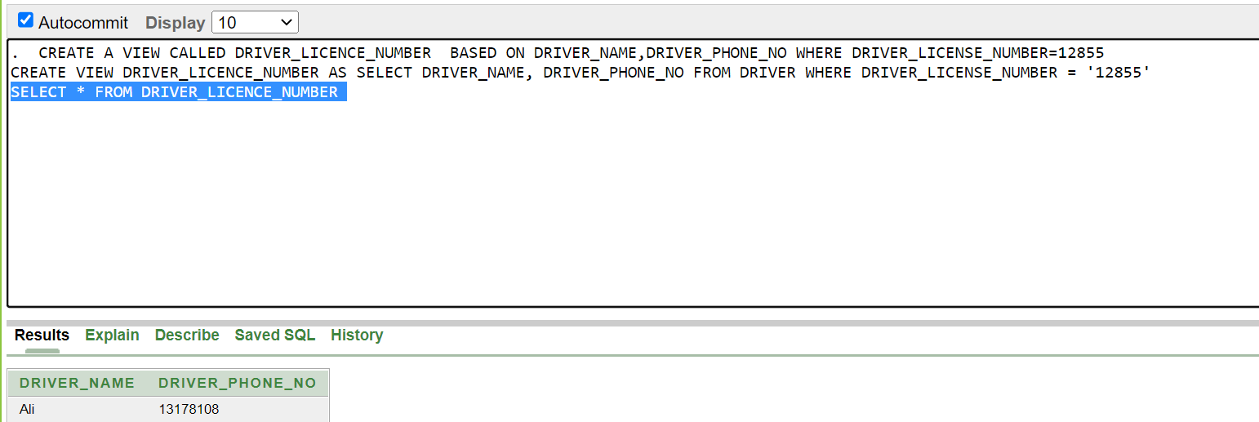

**2.COMPLEX VIEW:**

* Create a view for OWNER table where we are going to print OWNER ID,

OWNER Name,OWNER PHONE Number and OWNER Address from

OWNER table.

ANSWER: CREATE VIEW OWNER_view AS SELECT O.OWNER_id "OWNER ID", O.OWNER_Name "OWNER Name",O.OWNER_PHONE_NO "Phone Number", O.OWNER_address "Address" FROM OWNER O;

SELECT * FROM OWNER_VIEW;

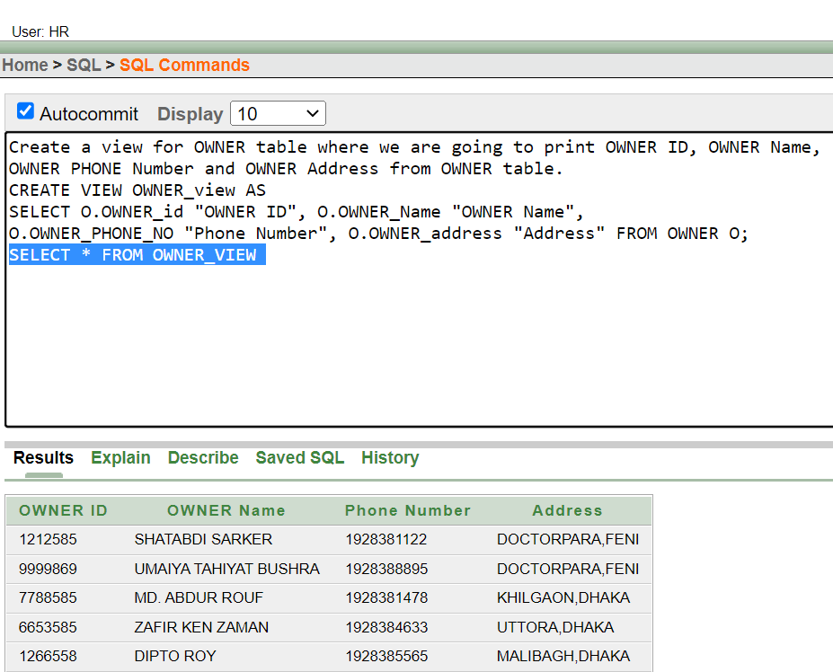

**CONCLUSION AND FUTURE WORK**

THIS IS A VERY SMALL SCENARIO OF A VEHICLE CONTROL AND INFORMATION MANAGEMENT SYSTEM. THE MAIN LACKING THIS APPLICATION IS ITS FEW FEATURES. IN REALITY THIS MANAGEMENT SYSTEM IS VERY BIG AND ITS STORED HUGE AMOUNT OF DATA. BUT IT MIGHT BE HELPFUL FOR THEM WHO WANTS TO BUILD THIS TYPE OF MANAGEMENT SYSTEM. THEY CAN TAKE THE IDEA FROM THIS MANAGEMENT SYSTEM.